Biofouling management plan template
Application of this template
This biofouling management plan template should be read with the Australian Biofouling Management Requirements.
To satisfy the requirements for option 1 of proactive biofouling management, the biofouling management plan and the biofouling record book must meet the department’s minimum standards as defined in the Australian biofouling management requirements Appendix A.
The minimum standards define the necessary information to be detailed in the biofouling management plan and record book to ensure the vessel operator can demonstrate proactive management of biofouling. It is recommended that the biofouling management plan and record book are tailored for your vessel including additional information as required.
The biofouling management plan template provides an example of the layout and content required to meet the department’s minimum standards for a management plan and has been adapted from the International Maritime Organization’s 2023 Guidelines for the control and management of ship’s biofouling to minimize the transfer of invasive aquatic species (resolution MEPC.378(80)).
- This template is provided as a guide only, operators are encouraged to customise this template to be vessel specific or choose to use an alternative plan that meets the minimum standards.
- This template is to be used as a tool to assist in the development or refinement of the vessel’s individual biofouling management plan.

Biofouling management plan

Introduction
Biofouling on vessels can be a significant vector for the transfer of invasive aquatic species. Biofouling management practices may also improve a vessel’s hydrodynamic performance and can be effective at enhancing energy efficiency, hence reducing air emissions from vessels as well as fuel consumption.

Vessel particulars
Name of vessel
IMO number
Date of construction
Vessel type
Gross tonnage
Beam or vessel’s breadth
Length overall (metres)
Maximum draughts
Minimum draughts

Record of the revision of the BFMP
This plan describes the biofouling management for the period between two scheduled dry-dockings which include application, re-application, installation or renewal of AFS. The plan should be re-evaluated and, if necessary, updated after a dry-docking and/or if any changes are made that have an impact on the anticipated biofouling.
Date:
Previous dry-docking facility name, address and date of entry and exit
Next scheduled dry-docking

The following revisions have been made:
Date | Full name and position of responsible person | Updated parts

Index
A table of contents should be included.

Operating profile
The vessel’s operating profile is described below and is the basis for the selection of the vessel’s anti-fouling systems (AFS) and operational practices. The following entries apply to the vessel’s in-service period between dry-dockings.
Typical operating speed (knots)
In-service period (months)
Typical trading areas | EXAMPLE:  North Sea and Baltic trade, European trade, Mediterranean, south-east Asia, global
Typical operating areas, including climate zones in which the vessel will operate | EXAMPLE:  Temperate, semi-temperate, tropical and/or arctic
AFS installed are suitable* for typical operating profile (Y/N)
*Suitable refers to the correct application, installation and use of AFS according to the AFS manual and the intended operating profile of the vessel.

Description of hull and niche areas where biofouling is most likely to accumulate
The hull and niche areas where biofouling is most likely to accumulate are described below.
Areas on the general hull | EXAMPLE:  Flat bottom – forward/bow  Flat bottom – middle/amidships  Flat bottom – aft/stern  Bow dome / bulbous bow  Boot top  Vertical sides – port side  Vertical sides – starboard side  Vertical side – aft/stern  Transom
Niche areas (including quantity where relevant) | EXAMPLE  Sea chests (x8)  Bow dome / bulbous bow (x1)  Bow thruster/lateral thrusters (including tunnel gratings, propeller blades, boss, gear box, sacrificial anodes, supporting frames, rope guard covers) (x1)  Azimuth thrusters (including attachment leg, rope guard covers, gear box, propeller blades, boss, kort nozzles, sacrificial anodes, etc) (x2)  Retractable azimuth thruster (including attachment arms/guides, void space, rope guard covers, gear box, propeller blades, boss, kort nozzles, sacrificial anodes, etc) (x1) Impressed Current Cathodic Protection (ICCP) systems  Bilge keels (x2)  Stabiliser fins (void space, stabilizer fins, sacrificial anodes, etc) (x2)  Rudders (upper and lower pintles, hinges, uniform/flat sides) (x2)  Dock block marks (x 88)  A-brackets/stern tube (x2)  Draft markers/hull markings (38)  Sea chests/box coolers (gratings, internal walls, cooling veins, Marine Growth Prevention System (MGPS) anodes, sacrificial anodes, intake pipes, etc) (x6)  Main propellors (propeller blades, boss, rope guard covers, etc) (x2)  Stern rollers (void space, roller) (x 1)  Echo sounders and speed logs (x2)  Acoustic Positioning Systems (x2)  Moon pools (smooth walled or baffled) (x1)  Free-flood spaces/voids (provide description)  Overboard discharges (below the waterline) (x23)

Location of areas where biofouling is most likely to accumulate on the vessel
A diagram of both side and bottom of the vessel identifying the location of each area that is most likely to accumulate biofouling should be included.
This section should contain at least one of the following:
- General arrangement
- Docking plan
- ISS schematics (all systems)
Figure 1: Example schematic of vessel identifying the location of each area that may accumulate biofouling.
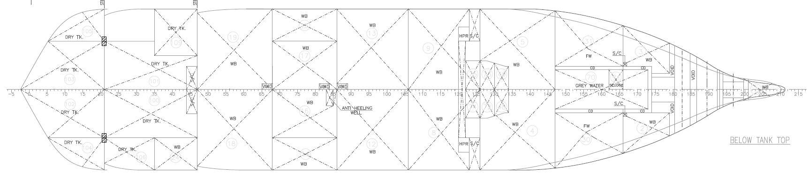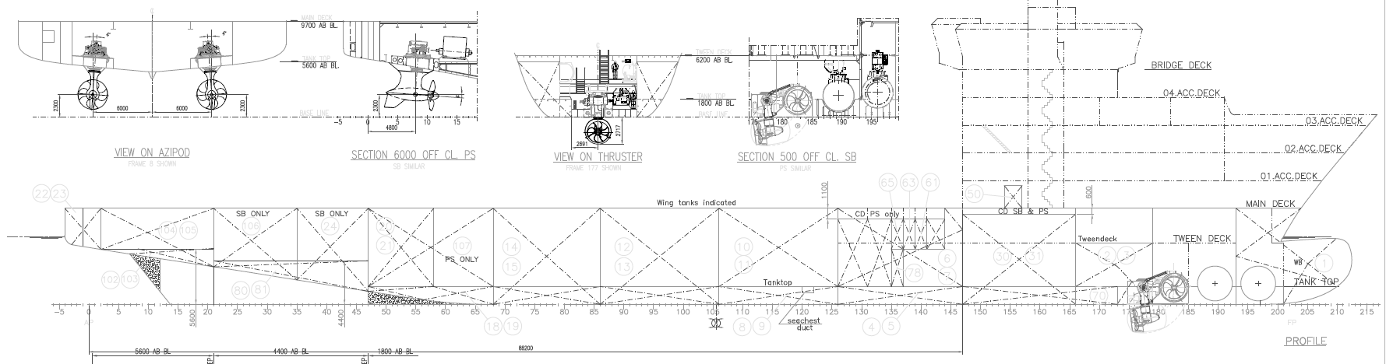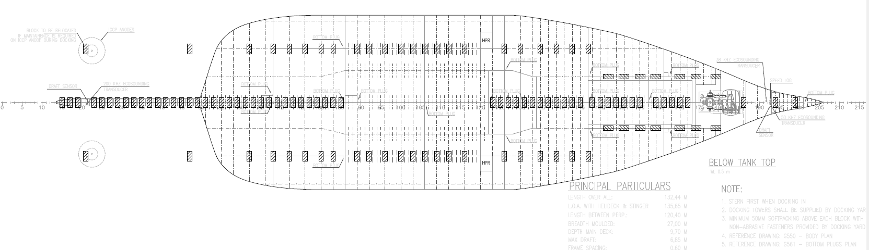
Sea chests
Propellers
Thrusters
DDSS and Bottom Plugs
Source: Biofouling Solutions

Description of the anti-fouling system (AFS)
The selected AFS applied, re-applied, installed or renewed on the vessel are described below. When more than one type of anti-fouling coating (AFC) or marine growth prevention system (MGPS) are applied, re-applied, installed or renewed, each AFS should be described individually and in accordance with each manufacturer’s instructions.
Prior to a scheduled dry-docking, an evaluation of qualitative observations regarding the vessel’s biofouling should be made with the purpose of a potential improvement of the AFS selection. Previous reports on the performance of the vessel’s AFS should be part of the evaluation.
Anti-fouling coatings (provide a new table for each AFC coating type)
Manufacturer(s)  Product name(s)  Type of coating(s)  Location(s) applied | EXAMPLE:  XX A anti-foulant and XX B anti-foulant  2-PAC epoxy, hard coating, self-polishing, fouling release, etc  XX A applied to uniform hull and XX B applied in all niche areas
Expected lifetime (effective coating service life) of all coatings applied | XX A = 60 months, XX B 90 months
Operating profiles which are suitable for the AFCs including speed, periods of activity and inactivity
Recommended regime for repairs, maintenance, and/or renewal to receive the AFC optimal performance | EXAMPLE:  Regime for repairs  Regime for maintenance  Regime for renewal  N/A
International antifouling systems (IAFS) certificate supplied in record book Y/N

Marine growth prevention systems (MGPS) (provide a new table for each MGPS system)
Manufacture  Model  Type | EXAMPLE:  anode, ultra-sound, electrode, electrolysis, ultraviolet radiation or other
Service life of MGPS
MGPS operating manual in record book Y/N

Other AFS (e.g. acoustic)
Manufacturer(s), model(s) and type(s) of other AFS
Type(s) of harmful discharge from other AFS
Operating conditions/frequency
Required maintenance and frequency
Service life and expiration date of AFS

Installation of anti-fouling system
The areas on the vessel which are protected with the selected AFS are described below. If necessary, the individual AFS could be identified as A and B, respectively. Areas with no protection are also described.
Anti-fouling systems (N/A if not protected)
Areas of vessel (All areas under section 6 to be listed here.) | AFS applied (List all relevant AFC, MGPS or other AFS) | Date of application/installation
EXAMPLE:  Flat bottom – forward/bow  Flat bottom – middle/amidships  Flat bottom – aft/stern  Bow dome / bulbous bow  Boot top  Vertical sides – port side  Vertical sides – starboard side  Vertical side – aft/stern  Transom | EXAMPLE:  AFC (A)
EXAMPLE:  Sea chests (x8) | EXAMPLE:  MGPS (A)
EXAMPLE:  Bow thruster/lateral thrusters (including tunnel gratings, propeller blades, boss, gear box, sacrificial anodes, supporting frames, rope guard covers) (x1) | EXAMPLE:  MGPS (B)
EXAMPLE:  Stabiliser fins (void space, stabilizer fins, sacrificial anodes, etc) (x2) | EXAMPLE:  MGPS (B)
EXAMPLE:  Dock block marks (x 88) | EXAMPLE:  MGPS (A)
EXAMPLE:  Moon pools (smooth walled or baffled) (x1) | EXAMPLE:  MGPS (C)
EXAMPLE:  Sea chests 5-6 | EXAMPLE:  No AFS
EXAMPLE:
Other AFS
EXAMPLE:
No AFS

Inspection schedule
An inspection will be carried out by organisations or personnel competent to undertake inspections according to the fixed intervals described below:
Hull and niche areas
Areas of vessel | Inspection schedule | Management actions
EXAMPLE:  Areas installed with AFS and operating within the profile | EXAMPLE:  Inspection within 12 months  When utilising a performance monitoring system that indicates adequate performance of the AFS, an inspection will be conducted within 18 months.  If the monitoring indicates that the AFS is not performing effectively, an inspection should be carried out as soon as possible.> | EXAMPLE:  If rating 0-1 in previous inspection, then inspection every 12-18 months.  If rating 2, 3 or 4 in previous inspection then more frequent inspections required.
EXAMPLE:  Areas with no AFS and no other measures | EXAMPLE:  Inspection within 12 months | EXAMPLE:  Inspection more frequently

MGPS and internal seawater systems
Areas of vessel | Inspection schedule | Management actions
EXAMPLE:  Areas installed with MGPS and operating in accordance with manufacturer’s recommendations | EXAMPLE:  Inspection once a month | EXAMPLE:  If rating 0-1 in previous inspection, then inspection every 6 months.  If rating 2, 3 or 4 in previous inspection then more frequent inspections required.
EXAMPLE:  Areas with no AFS and no other measures | EXAMPLE:  Inspection within 12 months | EXAMPLE:  Inspection more frequently

Cleaning schedule
Cleaning of the hull and niche areas carried out according to fixed intervals should be described.
Hull and niche areas
Areas of vessel | Cleaning method(s) | Cleaning schedule
EXAMPLE:  Flat bottom – forward/bow  Flat bottom – middle/amidships  Flat bottom – aft/stern  Bow dome / bulbous bow  Boot top  Vertical sides – port side  Vertical sides – starboard side  Vertical side – aft/stern  Transom | EXAMPLE:  Water jet and suction with capture according to [name of the standard] | EXAMPLE:  When recommended based on monitoring of biofouling parameters  and/or  in case unforeseen biofouling levels are detected on hull or in niche areas
EXAMPLE:  Sea chests, internal pipework, ballast intake system, inlet gratings | EXAMPLE:  Steaming with capture | EXAMPLE:  When recommended based on monitoring of biofouling parameters  and/or  in case unforeseen biofouling levels are detected in niche areas

MGPS and internal sea water systems
Areas of vessel | Cleaning method(s) | Cleaning schedule
EXAMPLE:  High suction sea chest sea strainer on port side | EXAMPLE:  Manual cleaning | EXAMPLE:  Once a month
EXAMPLE:  Sea chests, internal pipework, ballast intake system, inlet gratings | EXAMPLE:  Steaming with capture | EXAMPLE:  When recommended based on monitoring of biofouling parameters  and/or  in case unforeseen biofouling levels are detected in niche areas

Monitoring of biofouling risk parameters and contingency actions
Relevant digital tools applied for monitoring of biofouling risk parameters and/or digitalised real-data input are (describe the tools and data used for this vessel).
The biofouling risk parameters provided below should be monitored when the vessel is in operation. When a parameter exceeds the deviation limit, the risk of biofouling accumulation is increased, and the recommended contingency actions should be used as described.
Hull and niche areas
Biofouling risk parameters to monitor | Evaluation of a deviation including deviation limit of the risk parameter | Contingency actions | Long-term actions
EXAMPLE:  Deviation from operational profile acceptable for the AFS | EXAMPLE:  Incidental deviations should be evaluated for potential biofouling impact.  Continuous or regular deviations, or deviations not rectified should lead to contingency actions | EXAMPLE:  Shorter inspection interval with inspection every 4 months.  When recommended by the AFS manufacturer, more frequent proactive cleaning activities could be implemented between inspections | EXAMPLE:  Evaluate the need of a potential improvement of the AFS selection prior to the next dry docking
EXAMPLE:  Deviation from planned inspection/cleaning | EXAMPLE:  When proactive cleaning is implemented as part of the AFS, deviation from regular use could lead to increased risk of biofouling growth onto relevant submerged areas. | EXAMPLE:  An inspection should be carried out. If it is light microfouling/heavy microfouling (fouling rating 1/2) or more in the relevant area, reactive cleaning with capture should be performed before proactive cleaning is used again.  Maintenance or repair should be performed at earliest possible opportunity.  More frequent inspections should be implemented until the missing proactive cleaning is in regular use. | EXAMPLE:  Regular maintenance and repair e.g. may be necessary actions for proper protection by the proactive cleaning.  Evaluate the need to update maintenance program.
EXAMPLE:  Extended vessel idle time (berthed, anchored, moored) | EXAMPLE:  If the idle time is longer than estimated time in the vessel’s operating profile, it could lead to an elevated risk of biofouling.  If the idle time is beyond the guarantee of the AFS supplier, the risk of biofouling accumulation increases.  The risk also depends on biofouling pressure, e.g. temperature and distance to the coastline. If vessel is idle in an area far from shore (>200nm and >200m depth) and far from other installations, the risk may still be considered low. | EXAMPLE:  If the idle time is within the guarantee of the AFS supplier, a short voyage with speed as specified for AFS could be conducted, sea chests could be blanked off or, when recommended by the AFS manufacturer, more frequent proactive cleaning activities could be implemented.  If the idle time is beyond the guarantee of the AFS supplier, an inspection should be carried out. | EXAMPLE:  Evaluate the need of a potential improvement of the AFS selection prior to the next dry docking.

MGPS and internal sea water systems
Biofouling risk parameters to monitor | Evaluation of a deviation including deviation limit of the risk parameter | Contingency actions | Long-term actions
EXAMPLE:  Deviation from the maintenance/service regime of the MGPS | EXAMPLE:  If the maintenance and service time, specified by the manufacturer, is exceeded, the risk of biofouling is elevated, and contingency actions should be implemented. | EXAMPLE:  An inspection should be carried out for the relevant niche area where MGPS is installed.  Maintenance, calibration, or adjustment of treatment dosages for a MGPS should be performed at earliest possible opportunity. | EXAMPLE:  Regular maintenance and service (e.g) may be necessary actions for proper protection by the MGPS.  Evaluate the need to upgrade maintenance programme.

Capture and disposal of waste
In-water cleaning companies should arrange for capture of debris during cleaning. The biofouling waste should be disposed of and/or treated in a safe and environmentally sound manner, in accordance with local regulations.

Safety procedures for the vessel and the crew
Details of specific operational or safety restrictions associated with the AFC or MGPS systems that affect the vessel and/or the crew.
Details of specific safety procedures to be followed during vessel inspections and cleaning operations.

Crew training and familiarisation
Information on the provision of crew training and familiarisation on biofouling management. Should include crew who are trained and the person in charge of training.
Detailed description of how inspections are to be carried out by vessel crew as part of contingency actions.

Version history
The biofouling management plan template is updated periodically. You can check that this version is still current at agriculture.gov.au/biofouling.
Version | Date | Reason for issue
1 | December 2023 | First release of the document in line with the department’s new biofouling management requirements.

